PARTICIPANT (12+) INFORMATION SHEET
IRAS ID: 339327

Determining the feasibility of randomising children and young people to
invasive and non-invasive urine sampling techniques

The FROG Study

We would like to invite you to help us with our study

- Before you decide we would like you to understand why this study is being done and what is involved.
- A doctor or nurse will go through this information sheet with you and show you a video.
- Please ask questions about anything that might not be clear.

Why is this study being done?
Urine (wee) infections are common and can cause children to feel unwell with a high fever, stomach pain, and vomiting. When doctors and nurses think you might have a urine infection they test the urine. There are lots of different ways to collect a urine sample and we do not know which one is best.
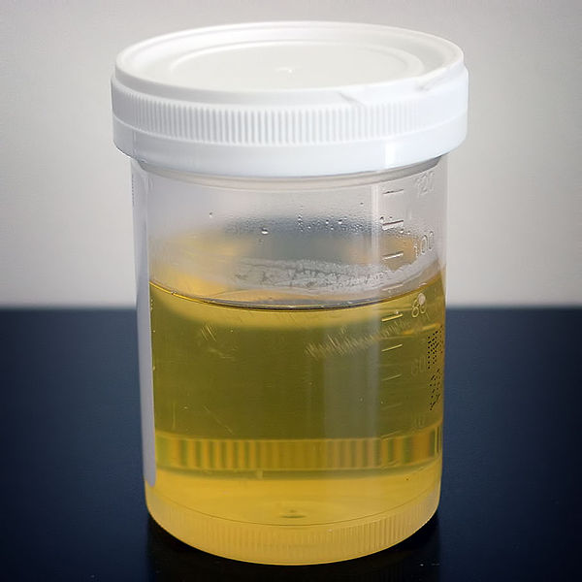
We need your help to find out whether it is possible to check which method of collecting urine is best.
https://commons.wikimedia.org/wiki/File:Urine_sample.JPG
Urine/wee sample

Why have I been invited to take part?
You have been invited because the doctors and nurses looking after you think you might have a urine infection and that a urine test is needed. The doctors and nurses are unsure of the best method to collect that urine sample for you.

Do I have to take part?
No and even if you say yes, you can change your mind at any time.

What will happen if I agree to take part in the FROG study?
If you agree to take part we will collect some information about you, the urine sampling method and treatment you receive.

If you agree to take part, a computer program will randomly select which method of collecting the urine sample you will receive. There are three ways to collect the urine:

- One way is to catch the urine in a container while you are doing a wee.

- Another way is to take the urine out of your body through a soft plastic tube that is inserted into the bladder through the tip of the penis or vagina.

- The other way is to take the urine out of your bladder using a needle passed through the skin of your tummy.

The doctors and nurses can explain each of the urine collection methods to you.

If you don’t want the computer program to select the method used to collect the urine sample, that’s ok. You can still take part in FROG.

Your parents will be asked to complete a questionnaires.
You and your parents will be asked if you would be interested in attending an interview about the study and/or a meeting to discuss the study results.

What are the benefits of taking part?
Whilst there are no immediate benefits, it is hoped that your participation will help inform us whether we can conduct a larger study in the future to assess the best methods of sampling urine.

What are the risks of taking part?
All the urine testing methods are used by doctors and nurses already. The plastic tube and needle methods can be painful, and the ‘clean catch’ method can be slow and provide unclear results. A doctor or nurse can explain the procedures in more detail including how long they will take and what pain relief is available to you.

What will happen if I don’t want to take part?
It is fine if you don’t want to take part in the FROG study. You will be looked after by the doctors and nurses and you will receive the treatment they feel is best for you.

What if something goes wrong?
The NHS hospital remains responsible for care during the study. If you have a concern about any aspect of the way you have been approached or you have been treated during the course of the FROG study, please contact the local Principal Investigator (contact details below), who will do their best to answer your questions. If you remain unhappy and wish to complain formally, you can do this through the normal NHS complaints service for your hospital (contact details below). In the event of you suffering harm as a result of taking part in this study, due to someone’s negligence, then you may have grounds for legal action against Queen’s University Belfast but you may have to pay your legal costs.

Is my personal information safe?
Your personal information such as your name and where you live will be kept confidential ‘private’, in keeping with the General Data Protection Regulations (GDPR). Your name and contact details will only be shared with people involved with the study, if you agree to being interviewed and/or attend a meeting.

What will happen to the results of the research study?
When the study is completed, we will share the results with the public and with people who provide the money to pay for studies. We will also share the results with you and your family.

Who is organising and funding the study?
The FROG study is being organised by a group of clinicians and led by Dr Tom Waterfield and Professor Kerry Woolfall. Dr Tom Waterfield is a Senior Academic at Queen’s University Belfast and a Consultant in Paediatric Emergency Medicine at the Royal Hospitals, Belfast, Northern Ireland. Professor Kerry Woolfall is researcher at the University of Liverpool. The FROG study is funded by the National Institute for Health and Care Research, Health Technology Assessment Programme. The sponsor of the study is Queen’s University Belfast. The study sponsor makes sure the research is conducted to a high standard to safeguard patient safety and data. There are no payments or reimbursement of expenses available to study participants.

Thank you for taking the time to read this Information Sheet
Contact Details
For any questions about the study you may contact the research team using the contact details below:
Principal Investigator: Update with local details
Name: «name»
Address: «address»
Telephone: «telephone»

Complaints/concerns: Update with details for local complaints department and/or Patient Advice and Liaison Service.
Name: «name»
Address: «address»
Telephone: «telephone»

Chief Investigator:
Name: Dr Tom Waterfield
Address: Wellcome-Wolfson Institute for Experimental Medicine,
Queens University Belfast,
97 Lisburn Road,
Northern Ireland,
BT9 7BL
Email: t.waterfield@qub.ac.uk
FROG Trial Co-ordinating Centre:
Address: 7 Lennoxvale,
Belfast,
Northern Ireland,
BT9 5BY
Telephone: + 44 (0) 28961 51447
Email: FROG@NICTU.hscni.net

