**PARENT/GUARDIAN INFORMATION SHEET**

**IRAS ID: 339327**

**Determining the feasibility of randomising children and young people to**

**invasive and non-invasive urine sampling techniques**

The **FROG** Study

**We would like to invite your child to take part in our research study**.

* Before you decide we would like you to understand why the research is being done and what it would involve for you and your child.
* A member of the study team will go through this information sheet with you.
* Please ask questions about anything that might not be clear.
* Please take time to read the information carefully and discuss it with family and friends if you wish.

**Thank you for your time to consider participation in the FROG study**

## **Why is this study being done?**

This study is about collecting urine from children and young people (CYP) who have a suspected urine infection. The aim of the study is to find out if it is acceptable and possible to enrol children and young people in a future clinical trial that will test the best method of collecting urine from CYP.  
  
Urinary tract infections (UTIs), also known as urine infections, are quite common among CYP. Approximately 1 in 10 girls and 1 in 30 boys will experience a UTI by the age of 16. These infections can cause symptoms such as high fever, stomach pain, and vomiting, which can be distressing for both CYP and parents.

Discovering UTIs early is important to prevent complications such as kidney damage. Discovering a UTI involves testing the urine for signs of infection. Tests can be affected by the cleanliness of the urine sample. Sometimes, contamination or dirt from the skin or the bottom area can accidentally be collected along with the urine. This might show an infection even when there isn't one and can result in unnecessary additional tests, follow up appointments and antibiotics for the child/young person.

How urine is collected plays an important role in preventing contamination. Ideally urine samples are collected using a ‘middle of the stream’ technique where the sample is obtained in the toilet or potty during the process of urinating by collecting urine from the middle of the stream. If a child is not potty-trained urine cannot be collected by a ‘middle of the stream technique’.

When the ‘middle of the stream’ technique cannot be used, urine can be collected by

(1) using a ‘clean catch’ method, this involves catching urine in a container when the child urinates,

(2) by placing a plastic tube (catheter) into the bladder through the urethra, or

(3) by inserting a needle directly into the bladder through the skin on the abdomen.

The ‘clean catch’ method is painless but is also slow and prone to contamination; as many as 1 in 2 urine samples collected by this method are contaminated. The catheter and needle collection methods are quick and have contamination rates as low as 1 in 100 urine samples, but these methods can be uncomfortable.

In the UK, clinical guidelines recommend the ‘clean catch’, method. Guidelines in Europe and the USA recommend using the catheter or needle method. Research is needed to determine the best method of collecting a urine sample. Before we can conduct a much larger clinical trial we need to determine if a larger trial is feasible and if parents, young people and children will agree to take part. The research team can provide you with a QR code to access a short video about the FROG study.

## **Why has my child and I been invited to take part?**

You and your child have been invited because the doctors and nurses looking after your child require a urine sample from your child, and your child cannot provide a ‘middle of the stream urine sample’. The doctors and nurses would like to determine the best way to collect that urine sample for your child.

**Do we have to take part?**

No, it is up to you to decide whether or not you and your child take part. If you agree to take part, you will be given this information sheet to keep and you will be asked to sign a consent form. You may still decide to withdraw your consent for your child’s participation at any time without giving a reason. If you decide that your child should not take part, this will not affect your legal rights or your child’s healthcare at any time, now or in the future.

**What is standard care?**

Standard care for the collection of urine varies between hospitals and between doctors, and can depend on why the urine sample and subsequent tests are required. Your doctor or nurse can inform you of what the standard care is at your hospital for collecting urine samples. All the urine sampling methods in this study are well recognised and accepted methods of urine sampling.

**What will happen if I agree for my child to take part in the FROG study?**

The FROG study is a small study to inform the design of a possible future clinical trial.

Before we can design that trial we need your help. If you agree for your child to participate in the FROG study, your research nurse will provide you with a consent form to complete, and we will collect your child’s health data and urine sample. This data and urine sample are routinely collected and tested as part of standard clinical care in relation to a suspected urinary tract infection. We will ask you or your child to complete two questions following the collection of the urine sample. We will also ask you to complete a Health Resource Use Questionnaire approximately 3-6 months from today.

In addition we would ask you to consider helping us by:

* Completing a Parent/Guardian Questionnaire
* Allowing your child to be randomised to one of the urine sampling methods today
* Agreeing to be contacted and if selected you and/or your child would be interviewed in the future
* Agreeing to be contacted and if selected you and your child would attend a meeting to discuss the study results

**Study Flow Chart**

Another way to find out what will happen during the study is to read the study flow chart below.

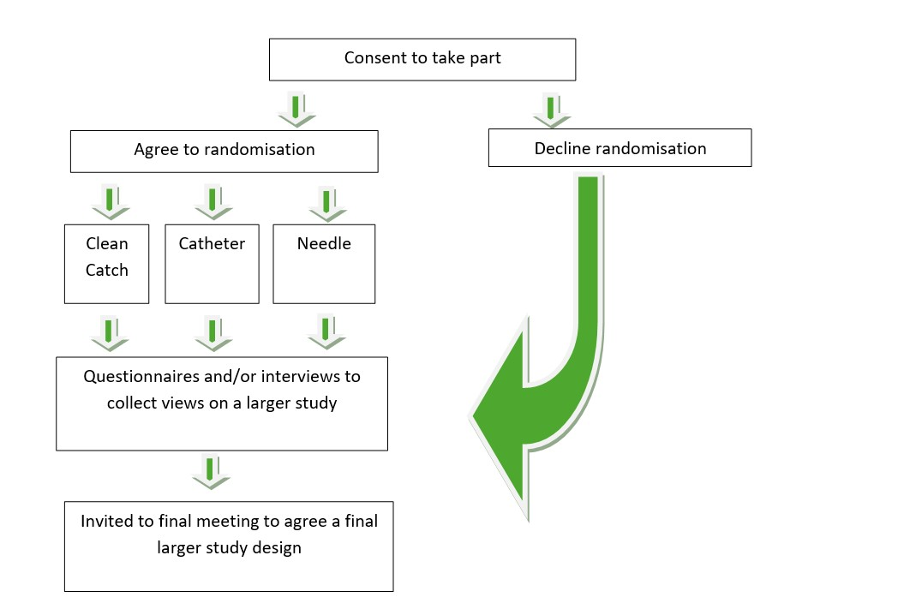

**You can choose which part of the FROG study to participate in.**

**What is involved in the Parent/Guardian Questionnaire and interview element of the FROG Study?**

Clinical trials can be difficult and costly to conduct and many struggle to recruit enough patients to answer the research question. By involving parents, children and hospital staff in clinical trial design we can help ensure the trial is acceptable and family-centred. We would like to invite you to complete a brief paper questionnaire of about 5 minutes duration (please ask a nurse or doctor). The questionnaire will ask your views about the proposed trial and your reasons for saying yes or no to your child’s randomisation to the urine sampling methods described above. It will also ask questions about what informed these decisions and anything we can do better when we approach parents about The FROG study in the future.

A researcher from the University of Liverpool would also like to talk to parents and children (if they are happy to take part) about the FROG study. If selected, these interviews will last between 40 - 60 minutes and will include similar questions to the questionnaire but in more detail. The aim of these interviews is to find out differing views on the urine sampling methods and the design of a future study. We want to hear a wide range of views and opinions, including **the views of parents opting not to consent to randomisation to one of the urine sampling methods. Your views are very important to us**.

Please let us know if you would like to participate in the questionnaire and/or interview by initialling the relevant boxes on the consent form. If you/your child consent to being contacted for an interview, you will be asked to provide your contact details. Please return these to the person who spoke to you about the research.

If you/your child are selected for interview, a researcher from The University of Liverpool will contact you by telephone and/or email to arrange the interview at a convenient time within the next month. Interviews will be conducted online, via telephone (whichever you prefer) or face to face if you live in the Northwest of England.

Before the interview, we will send a brief information sheet (like this one) which will be used to invite parents/guardians or children to take part in the FROG clinical trial.

Interviews will be professionally transcribed by a company called UK Transcription. After the interview, we will send each participant a £30 Amazon voucher to thank them for their time.

**What is involved in the randomised element of the FROG Study?**

If you also agree to your child being randomised to one of the urine sampling methods then a computer program will randomly select which method of sampling your child will receive, and you will be told the result. Neither you nor your child’s doctor can choose which group your child will be in. Your child could be randomised to either:

**Non-invasive urine sampling method:**

1. With a clean catch urine sample (urine caught in a little bowl)

(time it takes to collect urine approximately 30 mins)

**OR**

**Invasive urine sampling method:**

1. Placing a plastic tube (catheter) into the bladder through the urethra

(time it takes to collect urine approximately 5 mins)

**OR**

**Invasive urine sampling method:**

1. Inserting a needle directly into the bladder through the skin on the abdomen

(time it takes to collect urine approximately 5 mins)

It may not be possible to offer all the invasive urine sampling methods to all participants and if any are not available (or not appropriate) you will be informed, and your child won’t be randomised to receive them. Whichever group your child is in, they will still be looked after by the same team of doctors and nurses that are already treating them.

**What is involved in the meeting element of the FROG Study?**

The final phase of the study will involve a face-to-face consensus meeting bringing together Doctors, nurses, and parents to review all the information gathered during the study and seek consensus on whether or not a larger study comparing invasive and non-invasive urine sampling methods is feasible and acceptable to conduct.

Please let us know if you would like to participate in the consensus meeting by initialling the relevant boxes on the consent form.

If you/your child are selected to attend the consensus meeting, an invitation letter will be sent to you by email with details of the location, date and time of the meeting. Your travel expenses will be reimbursed to attend the meeting.

**What happens when my child’s involvement in this research study stops?**

Your child will continue to be looked after by their normal doctors and nurses.

**What are the possible benefits of taking part?**

Whilst there are no immediate benefits for your child taking part in this study, it is hoped that you and/or your child’s participation will help inform us whether we can conduct a larger study in the future to assess the best methods of sampling urine.

**What are the possible disadvantages and risks of taking part?**

All the urine sampling methods are widely available and routinely used. The clean catch urine sampling method is painless but can take a long time to collect and can be inaccurate resulting in the wrong treatments being given. The catheter and needle collected urine samples are far more accurate and quicker to collect but can cause discomfort. There is a small risk of infection when administering catheterisation and a small risk of blood contamination when administering suprapubic aspiration.

**Study Timeline**

|  |  |
| --- | --- |
| **Time** | **What will happen** |
| In hospital | Meet the doctor and study team. Receive Information Sheet.  If agreeable, provide informed consent:   * For data collection * For your child to be randomised to one of the urine sampling methods * To complete a Parent/Guardian Questionnaire * To be contacted to take part in interview * To be contacted to attend a meeting to discuss the study results |
| In hospital | You/your child complete a short questionnaire about the sampling method.  If you consent, complete Parent/Guardian Questionnaire. |
| Within 1 month | If you/your child consent to be contacted for interview and are selected:  Invited to share your views with researchers via an online or face to face meeting to understand how best to design a future study. |
| Within 3-6 months | Complete and return Health Resource Use Questionnaire. |
| Within 1 year | If you/your child consent to be contacted to attend a meeting and are selected:  Invited to attend a face-to-face meeting to discuss the study results |

**What will happen if I don’t want my child to carry on with the study?**

You can withdraw your child from the study at any time without giving a reason and your child’s care will not be affected. Your child will continue to be looked after by the normal team of hospital doctors and nurses and will receive the treatment they feel is best for your child. If you decide to withdraw your child from the FROG study, you should contact the study team at your hospital. Please speak directly with your research nurse or contact the PI at your local site if you or your child would like to withdraw from the study at any time. The contact details for the PI at your local site can be found at the end of this information sheet. If you withdraw your child from the study, we will use the data collected up to the time your child was withdrawn from the study.

What if something goes wrong?

The NHS hospital remains responsible for your child’s care during the study. If you have a concern about any aspect of the way you have been approached or your child has been treated during the course of the FROG study, please contact the local Principal Investigator (contact details below), who will do their best to answer your questions. If you remain unhappy and wish to complain formally, you can do this through the normal NHS complaints service for your hospital (contact details below). In the event of your child suffering harm as a result of taking part in this study, due to someone’s negligence, then you may have grounds for legal action against Queen’s University Belfast but you may have to pay your legal costs.

**Will information from the study be kept confidential?**

Any data which is collected about your child or from you during the course of the study will be kept strictly confidential and will only be seen by staff involved in the study from the NHS Trust, the Trial Co-ordinating Centre (Northern Ireland Clinical Trials Unit, Belfast Health and Social Care Trust), Queen’s University Belfast, University of Liverpool and people from regulatory authorities who ensure that studies such as this are carried out correctly. All of them will have a duty of confidentiality to you and your child as a research participant.

All your information relating to the study will be kept strictly confidential, unless, in rare circumstances where it is thought that you, your child, or someone else may be at immediate risk of serious harm, or if details of previously unreported criminal or poor practice is divulged. In these circumstances, the researchers have a statutory duty to share this information with the relevant authorities.

Because the NHS Trust will need to contact you after your child leaves hospital, the NHS Trust will need to keep a record of your name, address, and other contact details such as telephone number and email address.

You have the right to see your child’s personal health information related to the research study, but you will not be able to review some parts of the information until after the study has finished. When any information from the study is published, it will not contain personal information and it will not be possible to identify any individual participant.

The data collected from this study will be kept for at least ten years after its conclusion. Your child’s personal health data will be retained by the Trial Co-ordinating Centre, Belfast Health and Social Care Trust. If you consent to complete the Parent/Guardian Questionnaire, this data will be retained at the University of Liverpool.

If you/your child consent to being contacted to participate in an interview, your contact details will be shared with the University of Liverpool research team, who will be conducting these interviews. If you/your child consent to being contacted to attend a future meeting, your contact details will be shared with the University of Liverpool and the Trial Co-ordinating Centre. Contact details provided will only be retained until the study has been completed.

The data collected as part of the FROG study may be shared and used in other research studies but if it is used in this way all personal identifiers will be removed and it will not be possible to identify any individual.

**What will happen to the results of the research study?**

Recruitment will commence in 2025 and the study is expected to take 1-2 years to complete. It is envisaged that publication of the results will follow shortly after this, through medical journals, websites, press releases, and via appropriate support groups. The results will also be presented to other doctors and nurses at meetings and conferences. Names of participants will not appear in any reports or publications arising from the study. If you would like to receive the study results, please let the study team at your hospital know and provide your contact details. Your contact details will be shared with the Trial Co-ordinating centre, who will provide you with a copy of the results at the end of the study.

**Who is organising and funding the study?**

The FROG study is being organised by a group of clinicians and led by Dr Tom Waterfield and Professor Kerry Woolfall. Dr Tom Waterfield is a Senior Academic at Queen’s University Belfast and a Consultant in Paediatric Emergency Medicine at the Royal Hospitals, Belfast, Northern Ireland. Professor Kerry Woolfall is researcher at the University of Liverpool. The FROG study is funded by the National Institute for Health and Care Research, Health Technology Assessment Programme. The sponsor of the study is Queen’s University Belfast. The study sponsor makes sure the research is conducted to a high standard to safeguard patient safety and data. There are no payments or reimbursement of expenses available to study participants.

**Who has reviewed the study?**

This research has been reviewed and given a favourable opinion by an independent group of people, called a Research Ethics Committee (REC), to protect your child’s safety, rights, well-being, and dignity. The Ethics Committee is completely independent from the study team. Your local NHS trust has given approval for the study to take place at your hospital.

**What happens if I have any questions, concerns or complaints about the study?**

If you have any questions about your or your child’s participation in this study or concerns about the way it has been carried out, you should contact the local Principal Investigator or a member of the research team at your hospital (contact details below).

**How long can I think about my child joining the study?**

Once your child has been confirmed as eligible for the study you will have approximately

1 hour to make your decision.

**Thank you for taking the time to read this Information Sheet**

**Contact Details**

For any questions about the study you may contact the research team using the contact details below:

**Principal Investigator:** *Update with local details*

Name: «name»

Address: «address»

Telephone: «telephone»

**Complaints/concerns:** *Update with details for local complaints department and/or Patient Advice and Liaison Service.*

Name: «name»

Address: «address»

Telephone: «telephone»

**Chief Investigator:**

Name: Dr Tom Waterfield

Address: Wellcome-Wolfson Institute for Experimental Medicine,

Queens University Belfast, 97 Lisburn Road, Northern Ireland, BT9 7BL

Email: t.waterfield@qub.ac.uk

**FROG Trial Co-ordinating Centre:**

Address: 7 Lennoxvale, Belfast, Northern Ireland, BT9 5BY

Telephone: + 44 (0) 28961 51447

Email: FROG@NICTU.hscni.net

**Transparency Statement**

Queen’s University Belfast is the sponsor for this study. The study sponsor is the organisation responsible to ensure the study is carried out to a high standard to safeguard patient rights and safety, and the quality of the research data.

**How will we use information about you?**

We will need to use information from you for this research project. This information will include your name/contact details. People will use this information to do the research or to check your records to make sure that the research is being done properly. People who do not need to know who you are will not be able to see your name or contact details. Your data will have a code number instead. We will keep all information about you safe and secure. Once we have finished the study, we will keep some of the data so we can check the results. We will write our reports in a way that no-one can work out that you took part in the study.

What are your choices about how your information is used?

* You can stop being part of the study at any time, without giving a reason, but we will keep information about you that we already have.
* We need to manage your records in specific ways for the research to be reliable. This means that we won’t be able to let you see or change the data we hold about you.

Where can you find out more about how your information is used?

You can find out more about how we use your information at [@]: <https://www.hra.nhs.uk/planning-and-improving-research/policies-standards-legislation/data-protection-and-information-governance/gdpr-guidance/templates/template-wording-for-generic-information-document/>

At [@]: <https://www.qub.ac.uk/privacynotice/Research/ListofResearchPrivacyNotices/PrivacyNoticeforResearchParticipants.html>

* by asking one of the research team
* by sending an email to the FROG study team: [FROG@nictu.hscni.net](mailto:FROG@nictu.hscni.net)